# Gitlab安装

## 下载gitlab安装包

|  |
| --- |
| sudo wget https://downloads.bitnami.com/files/stacks/gitlab/8.7.5-0/bitnami-gitlab-8. 7.5-0-linux-x64-installer.run |

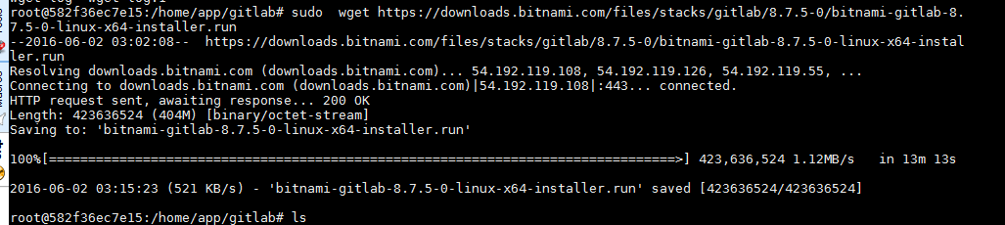

## 安装

|  |
| --- |
| sudo chmod a+x bitnami-gitlab-8.7.5-0-linux-x64-installer.run |



